**AN INTEGRATED DEVELOPMENT OF A YOUTH PROGRAM MANAGEMENT AND PARTICIPATION SYTEM FOR BARANGGAY LONGOS**

A Thesis Project Presented to the

Faculty of Datamex College of Saint Adeline, Inc.

In Partial Fulfillment of the Requirements for the

Degree of Bachelor of Science Information Technology

Presented By:

Bognalbal, Annel Josh

Boctoy, Jan Pauline

Gatmaitan, Russel

Ogatia, Shaicylle T.

August 2025

**DESIGN DOCUMENT**

**INTRODUCTION**

This document outlines a detailed proposal for the development of a Youth Program Management and Participation System (YPMPS) for Barangay Longos region. The system is intended to facilitate the access and distribution of community programs and activities as well as the other related services. This document intended as the primary record of the development, implementation, and support of the Youth Program Management and Participation System . it consolidates the system’s architecture, database , interface design, performance targets, and system security within the boundaries of maintenance philosophy. This document aims to align all concerned parties, such as the development group, project managers, and barangay leaders, on the plan for system development, implementation, and support. The document additionally guarantees that the design adheres to the objectives stated within the initial proposal of the project, which had the goal of improving the communication and participation of the youth in the barangay's activities.

**OVERVIEW**

The Youth Program Management and Participation System (YPMPS) is a web-based platform developed using HTML, CSS, and JavaScript, with options for database integration in future versions. The system centralizes information about youth programs, announcements, activities, and services. It addresses the limitations of traditional communication methods (physical bulletins, scattered social media posts) by providing a centralized, easy-to-access platform. The system includes modules for Dashboard, Programs & Services, Media Gallery, Contact & Participation Form, Reports, and Settings.

Currently, barangay youth programs and updates are spread across differentplatforms, making it difficult for residents to stay consistently informed. The new system will centralize all updates into a secure and structured digital format, which will allow youth and residents to access information quickly and reliably. This will not only reduce redundancy and confusion but also enhance participation by making events, services, and opportunities more visible and accessible.

**SCOPE OF DESIGN DOCUMENT**

The document articulates the architectural plan of the entire system including the proposed sample tables and fields of the system’s database. Describe the components of the system and the component’s interactions as well as the descriptions accompanying them, data movement within the system, and system security and performance parameters with respect to errors as well as subsequent handling. Also, describe the system deployment and system maintenance parameters. In the first phase of the system, mobile access and sophisticated backend capabilities will not be integrated, focusing user interface only.

**SYSTEM ARCHITECTURE**

**System Architecture Overview**

The Youth Program Management and Participation System (YPMPS) follows a client-server model where the application is accessed by residents through their web browsers, and the server delivers pages, multimedia, and content. This ensures that the system remains simple, widely accessible, and secure.

**High-level Components**

The key modules of the system are

- Youth Program Management – Centralized profiles of all programs and services.  
- Announcement Management – Records all barangay announcements and updates.  
- Media Gallery – Stores images and videos of past and upcoming events.  
- Participation & Contact – Provides forms for youth to join programs or reach officials.  
- Reports – Generates summaries of activities and program participation.  
- Settings – For administrators to update site details.

**Deployment Architecture**

The system runs on shared or cloud-based hosting providers.  
- Accessible via web browsers on desktop and mobile.  
- Files stored on the server with backups maintained externally.  
- Communication supported through HTTPS and SMTP.

**Communication Protocols and Interfaces**

Residents of the barangay, as well as staff and other officials, have the ability to access and manage a variety of official documents, including announcements, forms, and reports, from the barangay's website. As an added security measure, the system’s residents and administrators connections are protected by standard web protocols (HTTP/ HTTPS).

**DATABASE DESIGN**

**The Entity Relationship Diagram (ERD) consists of these core entities**

- Programs – Manages program details (ProgramId, Title, Description, Date, Status).  
- Participation – Tracks who joined which program (ParticipationId, UserId, ProgramId, Feedback).  
- Announcements – Stores barangay updates (AnnouncementId, Title, Content, Date).  
- Media – Manages uploaded files like photos or videos (MediaId, FileName, Type, LinkedProgramId).

**Data Normalization**

The schema ensures that youth and residents can be linked to activities and announcements while maintaining clean and consistent data. Data normalization up to Third Normal Form (3NF) is applied to reduce redundancy and ensure scalability.

**USER INTERFACE DESIGN**

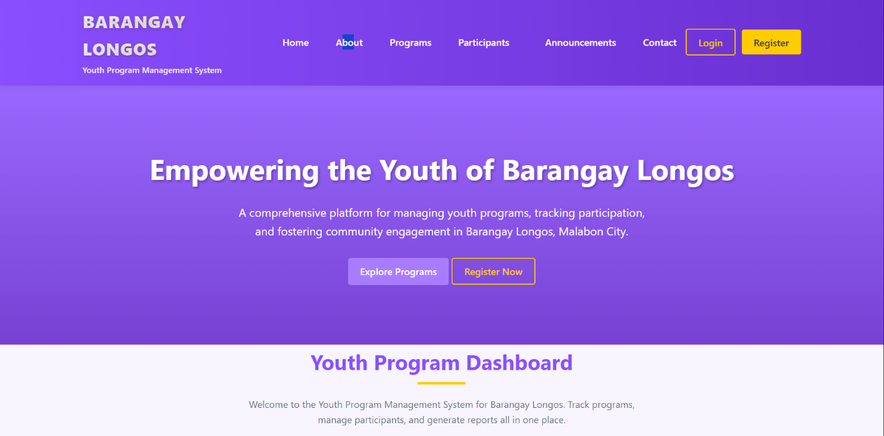

Dashboard-Presents an overview of total current programs, upcoming events, and announcements.

**Communication and Announcements** – Provides updates, announcements, and important information to youth members about upcoming activities and opportunities.

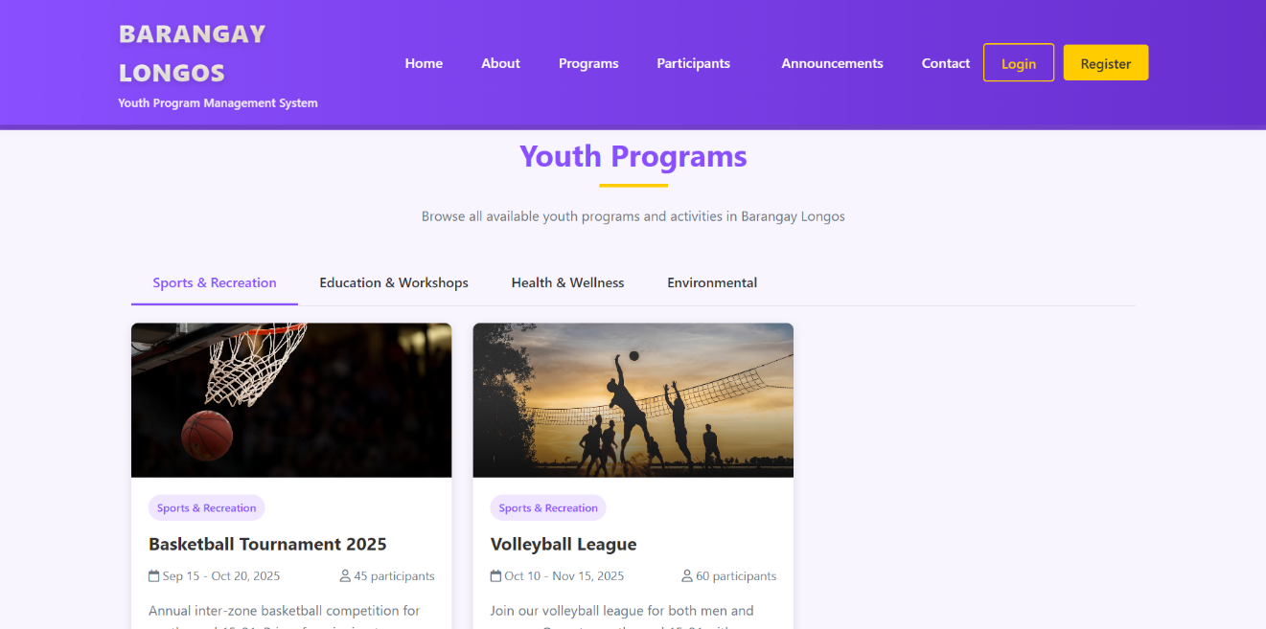

**Benefits and Community Engagement** – Encourages active youth participation, strengthens their connection with the barangay, promotes inclusivity, and ensures easier access to information, services, and programs that support community development.

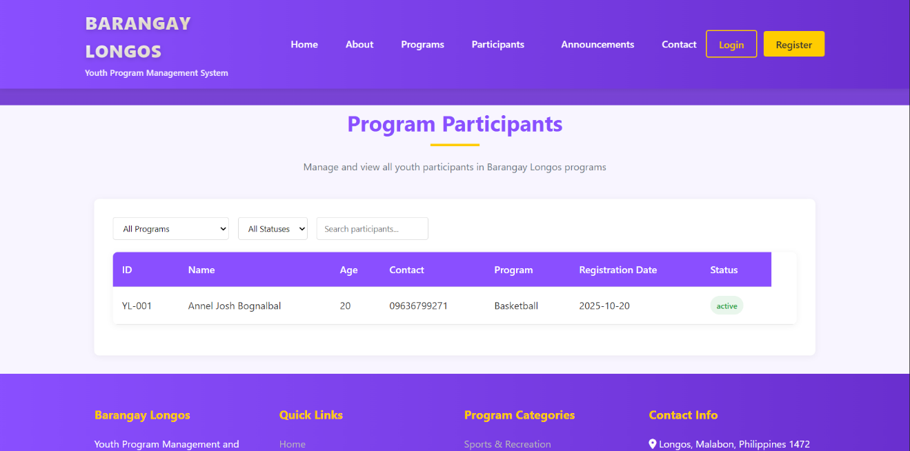

**Services and Programs** – Showcases available barangay services and youth programs that members can join or access.

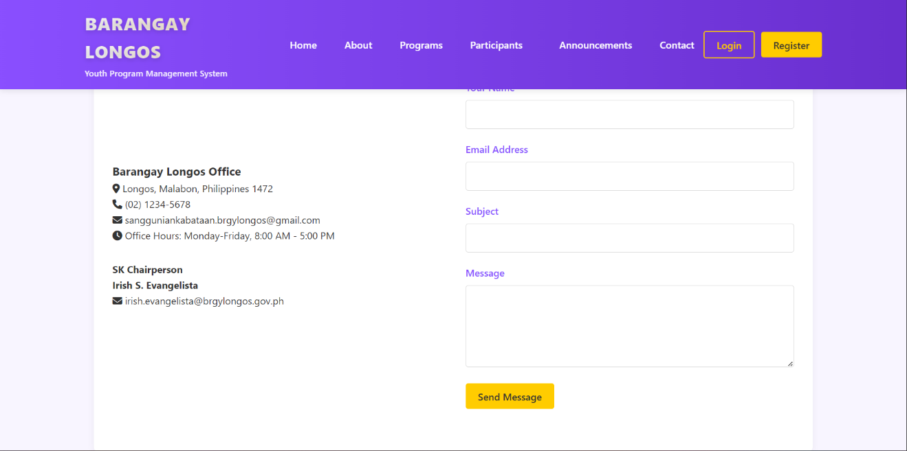

**Contact and Social Media** – Provides the official contact details and social media accounts of Barangay Longos for easier communication and wider access to news and updates.

**DESIGN PRINCIPLES AND USABILITY CONSIDERATIONS**

The system will be designed using a clean and uncluttered interface to allow users, especially the youth, to easily locate and understand the system functionalities. The system will have a responsive interface enabling seamless access from computers, tablets and mobile phones.

**COMPONENT DESIGN**

Program Management Module - Administers youth program records through CRUD operations by entailing program title, description, objectives, participants, and schedule. Links program with activity, participation, and reports.

Announcement Module - Creation and management of official barangay announcements from the officials would enable their timely dissemination of updates and events.

Media Module - Photos and videos of the programs and activities are to manage uploads, storage, and presentation of content, showcasing events, and promoting initiatives.

Contact and Social Media Constructs - giving feedback, and announcements about Barangay Longos, it provides formal contact information and social media links to increase reach and accessibility.

Services and Programs Block - Applicable permits, requirements, and descriptions of barangay services and youth programs for the easy accessibility of opportunities.

Google Maps Component - Shows Barangay Longos, giving a clearer picture for the user about the location of the barangay office and program venues.

Benefits and Engagement by the Community - Presents the positive face of the system in terms of encouraging the youth for such an inclusion

**DEPENDENCIES**

Its parts are dependent on one another such that some modules are not operational without the presence of others. These interdependencies mirror real-world youth program management and participation processes such that information remains accurate and consistent in the Youth Program Management and Participation System for Barangay Longos.

Announcements are dependent on Programs- Announcements do not operate in a vacuum but are attached to actual youth programs or barangay events. Announcements in practice are made by barangay officials to spread word regarding certain events, timetables, or openings among the youth.

Media relies on Programs and Announcements- Images and videos entered into the system are always associated with either a program or an announcement. For instance, a video for a youth outreach activity or images of a sporting event must be associated with the relevant program record. This makes media files meaningful, organized, and gives an eye witness account of activities, and not abandoned or useless files.

Services and Programs rely on Program Management- The Services and Programs Module is dependent on the Program Management Module. A service or program cannot be presented to the youth until it has been formally created and saved in program records.

Contact and Social Media- Are dependent on Announcements and Services. The Contact and Social Media Module is the barangay's contact bridge. Yet, its news are taken from the data generated in Announcements and Services. If these are absent, contact channels would have nothing to communicate.

Google Map- relies on Program and Services Data.The Google Map Module indicates the place where Barangay Longos is situated. Its significance is derived from being connected to programs and services, as youth must learn where activities and services are located. The dependence ensures that the map facilitates real events and offerings, and it becomes an effective tool rather than an independent feature.

Benefits and Community Engagement- are based on All Modules This module is an indication of the overall result of the system.

**DATA FLOW DIAGRAMS**

**User Flow:**

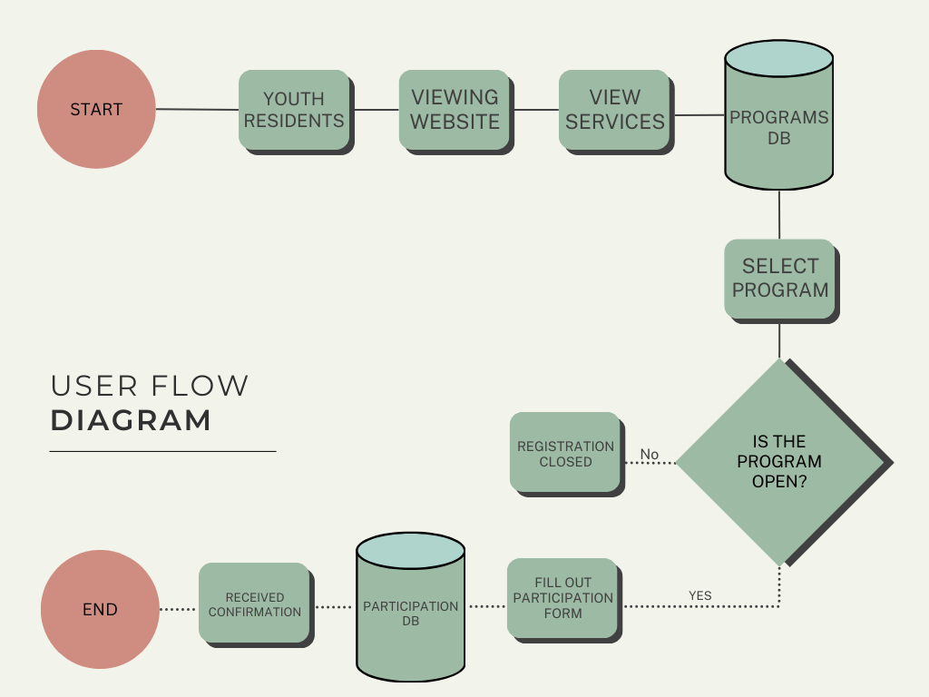

***Image . User Flow***

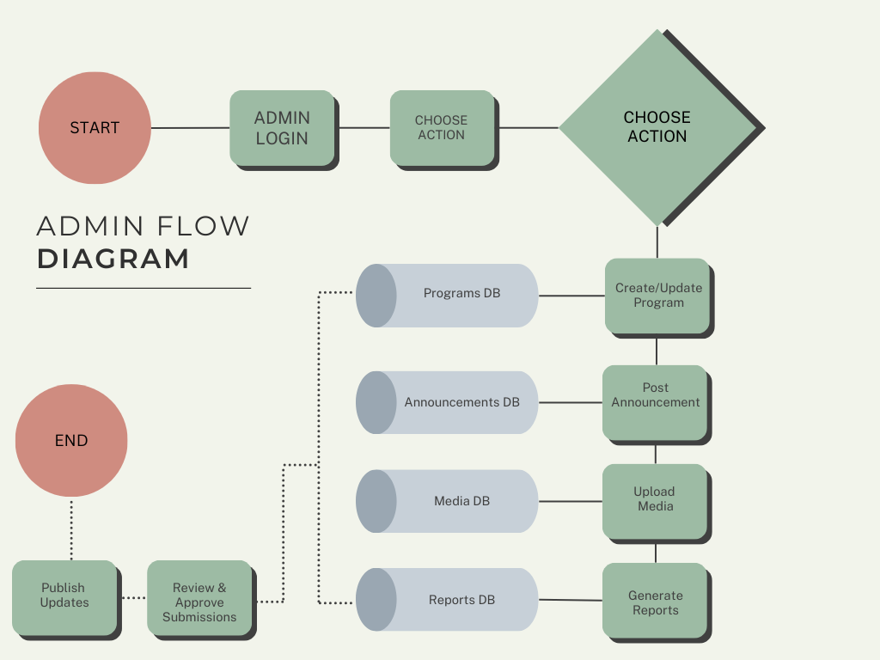**Admin Flow:**

***Image . Admin Flow***

**SECURITY DESIGN**

Accessibility - The system is a computer web-based platform, which is open access, meaning that anyone in the community is able to access it freely without logging in. This is more welcoming and considerate, particularly for the youth, as they can check on programs, announcements and services 24/7 through their phones and or devices.

Data Protection - Program details, announcements, and other contact information, even though the system can be accessed freely, are well protected and secured. Users are protected as well due to the system’s HTTPS which is a secured website, hence all data that is transferred and or received between the users and the system is kept safe.

System Reliability - The platform is designed for use on any device - be it a desktop, tablet or smartphone. It is user friendly as it is able to load quickly and as a result youth and residence are always able to access the information they are looking for without any inconveniences.

PERFORMANCE DESIGN

Optimized queries - The system’s database is architected in a way that important data such as programs, announcements, services, and media is loaded and displayed in a timely manner. Optimized queries allow users to access updates in real time so that users don't have to wait, even as the system scales.

Batch processing for reports - The system is designed to generate reports such as community activities and program summaries in which data is processed in batches. This prevents any slowdowns while ensuring that data is presented promptly and with proper accuracy.

Pagination and search - The system designed for announcements, services and media galleries allows for pagination and a simple search. This saves time so that users do not have to be bombarded with the information all at once.

Performance Testing - The system is continuously tested to ensure that multiple users are able to access the announcements, services and videos pages simultaneously and that the load time remains low and accessible. This guarantees that the entire users within the community have a positive experience.

ERROR HANDLING

Error Handling – Even forms such as inquiry forms filled out by residents as well as forms through which officials post new announcements are verified by the system. It minimizes the typical mistakes of invalid emails as well as omission of necessary questions. This guarantees that the information given to the community is not misleading and is clear.

Logging – During the system’s operation, it documents the moments when the new announcement is made, a new program is updated, or a new media file is uploaded. Each action made is noted with corresponding date and time which allows easy confirmation of the actions that were taken. This promotes efficient monitoring of modifications to ensure transparency.

Error Messages – In the case that a mistake is made, the system displays messages that are simple and easy to understand for all users. Like Error 404: Page Not Found, instead of confusing code that is not familiar to another user,

THIRD PARTY INTEGRATIONS

While the Barangay Youth and Community System is predominantly a standalone web platform, it does integrate a few other services to make it more engaging and useful. Furthermore, Google Maps is integrated so that users, especially the youth members, can navigate easily to the barangay hall and other relevant places. There are also an announcements, programs and services which are kept in the barangay’s full control, simplified, and managed directly within the system to benefit from these well-known tools.

YouTube – Embedded videos for programs.

Google Maps – Barangay Hall location.

DEPLOYMENT PLAN

Project files – All the system components are exclusively designed in HTML, JavaScript, and, CSS. This implies that web pages, scripts, and stylesheets are consolidated in a folder, and this folder is ready for deployment.

Send to the web Server – The project archives are sent to any web hosting provider, be it shared hosting, cloud hosting or even in free platforms like GitHub Pages. The moment these archives are sent, the system is instantly available via a web browser.

Integrated systems – The integrated systems of the application are, Youtube videos, social networks, and, Google Maps. These systems are curated to ensure that they render and execute correctly.

Backup – The system is static and the only form of backup involves transferring the project files which include HTML, CSS, JavaScript, images, plus other media files. These are uploaded to a cloud, external drives or, on USB flash drives to help in easy retrieval.

MAINTENANCE AND SUPPORT

System Maintenance - Scheduled routine maintenance involves adding and deleting web and document content such as new programs, announcements, new services, and media. This contains out-of-date content deletion and external system integrations (YouTube videos and social media, Google Maps and others) re-checking and ongoing confirmation of mobile accessibility. Small size corrections such as broken links, excessive delays page rendering, and style template obsolete replacements are among regular maintenance. Unbroken page and prompt access of the site members are maintenance objectives.

User Support - System open access and no login and forget password functions means system login support is unnecessary. Most support focus is to help residents in web site structured navigation. Users help themselves using clear instructions and labeled menus. Framework of the layout helps users to reach desired output with no confusion. Barangay site managers are provided with short and simple guides as a protective measure to assist them in the event of announcements modification and progressive content upload, to add new program data, and fill in provided forms.

Escalation - When there are problems that the Barangay staff are unable resolve—like showing embedded maps wrong, broken video links, or problems with the layout on certain gadgets—these are escalated to the development or technical support team. It is their job to examine the code, make file amendments, and redeploy the fixes.

REVISION HISTORY

|  |  |  |  |
| --- | --- | --- | --- |
| Date | Version | Description of Change | Author(s) |
| August 14, 2025 | 1.0 | Draft of Project Proposal | Project Team |
| August 18, 2025 | 1.1 | Revision of Project Proposal | Project Team |
| August 25, 2025 | 1.2 | Finalization of Project Proposal | Project Team |
| August 30, 2025 | 2.1 | Developed full Design Document with architecture, DB design, and deployment. | Project Team |

*Table 1. Revision History*